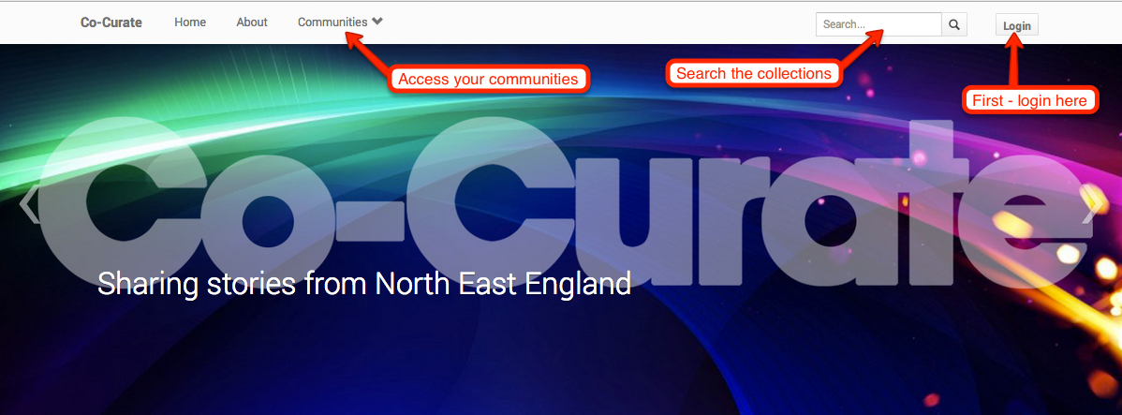
Access the Website at: https://co-curate.ncl.ac.uk
Search: You can search this site individually or in groups and look for all kinds of different materials from the North East of England.

There are lots to choose from- explore over 20,000 photographs, videos and other resources from Museums and other collections.

Share: You can share and upload your own photographs, films, stories, music, 3D scans and memories from the work you do as individuals and groups in school.
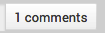

Login and add to the discussion - share your thoughts or upload your images in your community.

Detailed Instructions:  https://co-curate.ncl.ac.uk/help | Select: You can select materials from the online collections and materials uploaded by you and curate new exhibition spaces on the site about the projects you are working on.  Login and create a new page in your community. Select resources from the collection or add images, videos and links from the Web.
