Co-Curate Website - Instructions

Welcome to the Co-Curate North East Website. You have been given access to:
Co-Curate Community  https://co-curate.ncl.ac.uk/topics/ | Pages are public and can be viewed without login
George Stephenson High School  https://co-curate.ncl.ac.uk/communities/11/view/ | Pages can be accessed only by members of the community

Overview
- Access the Website at: https://co-curate.ncl.ac.uk
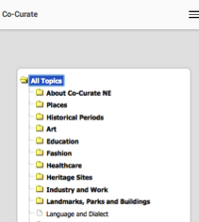
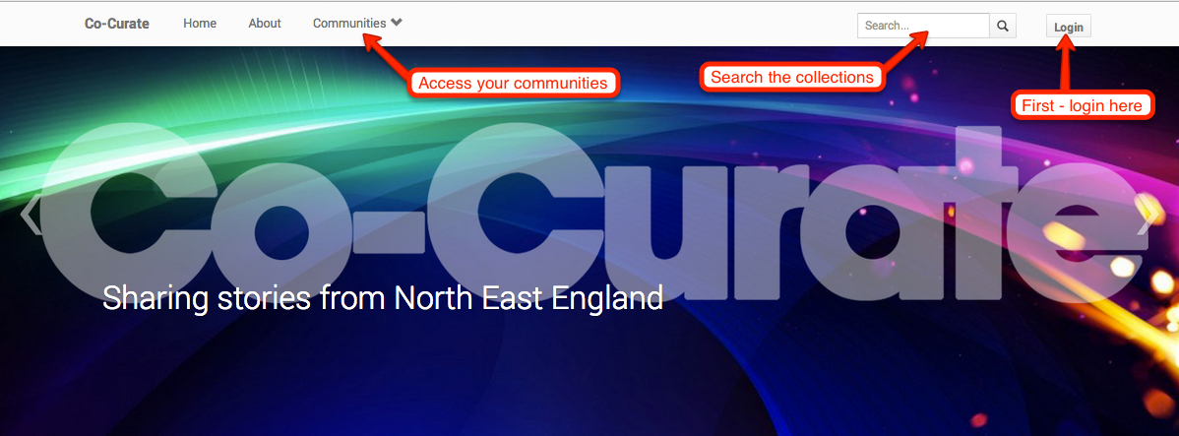
Responsive design: layout adapts to work on small screens e.g. smart phones

Website features

Access
- Pages can be viewed by the public (unless the page is part of a private community).
- You need to login to add resources, edit pages and join communities.
- Click on the ‘Login’ button (top right)
- There are 3 ways to login (to edit content and tag resources):
  - With your Co-Curate account (can be created on request e.g. for Schools and community groups)
  - Social login (c/o Twitter, Google)
  - Newcastle University login
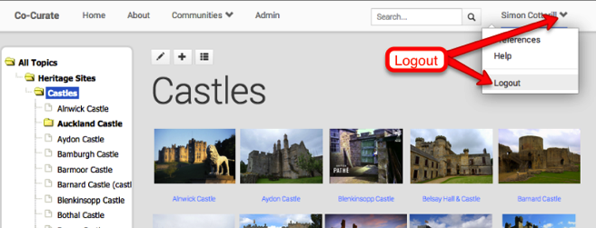
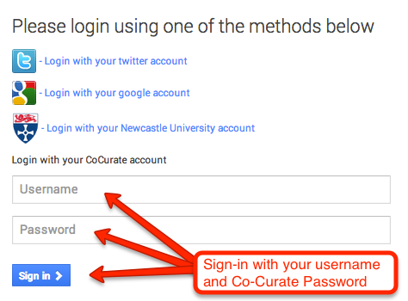
Logout – via top-right menu
Changing your password: If you have a Co-Curate account you can change your password via the Preferences section (top-right menu after login). This is not available if you have used University or social login.
Forgotten your password? If you have forgotten your Co-Curate password then click on the “Forgot Password?” button to get an Email with a link to reset your password. If you have forgotten your social login password (Google, Twitter) then use the relevant system to reset your password.

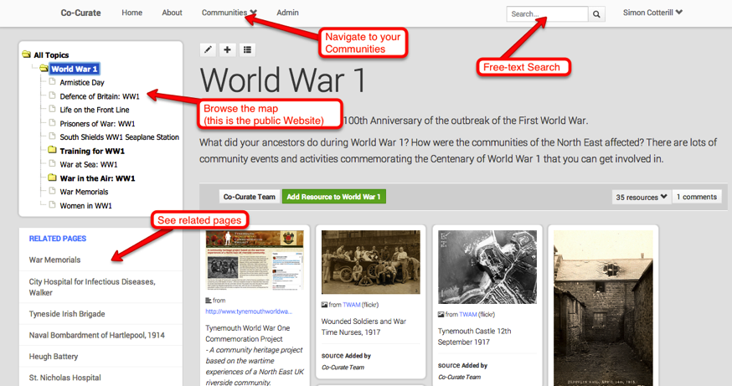
Navigation
- Navigate by browsing the left-hand menu or via free text search:
You can access public topics at: https://co-curate.ncl.ac.uk/topics/

Communities
- Can be:
  - Public – open, anyone can login and join
  - Private – closed, externals can’t join (e.g. for most Schools)
- Have separate left-hand menus
To join a community:
- Click on the ‘Communities’ menu (top-left)
- Click on ‘View All Communities’
- Click on ‘Join’ next to the desired community(s)
Hint: please do join the Co-Curate NE community
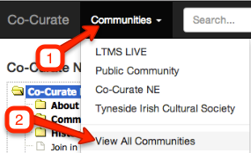
- Contact the team to request a community for your group / school.

Creating / Editing Pages (requires login and community membership)
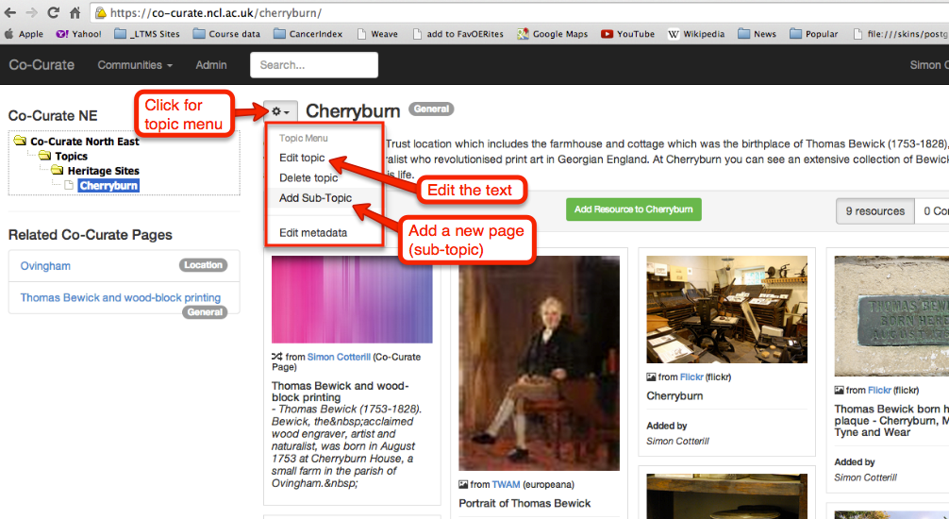
- Advanced editor:
  - Include links, images, lists etc. within the content area
  - Supports superscript (for references)
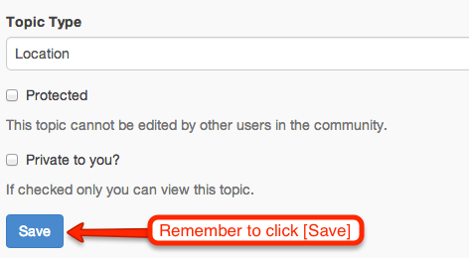
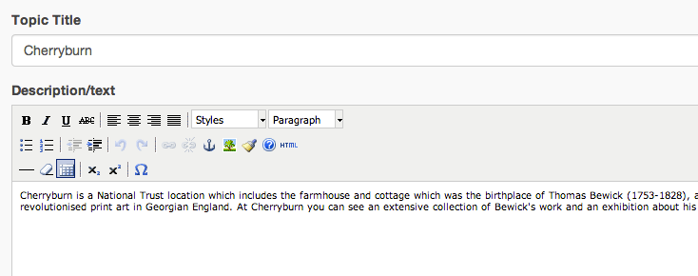
Hint: your content can be as long as you
want – but for a Web-based audience it
is best break down lengthy texts into
smaller sub-topic pages.

Adding Resources
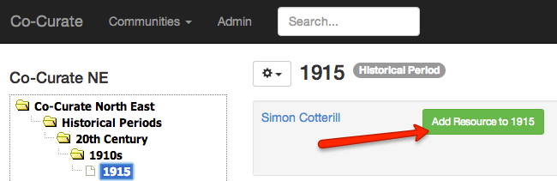
- Click on the green “Add Resource” button to launch the pop-up:

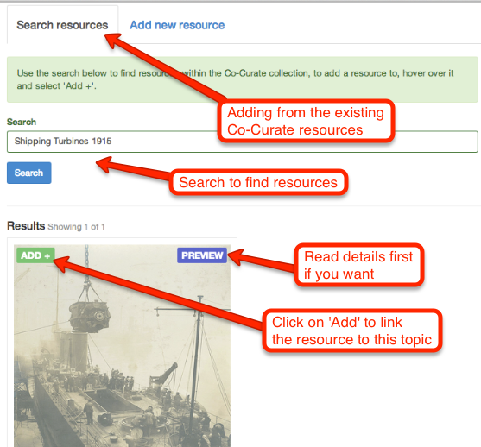
- If you add a Co-Curate page then it will also be listed under “Related Pages”.

Adding a link to an external resource

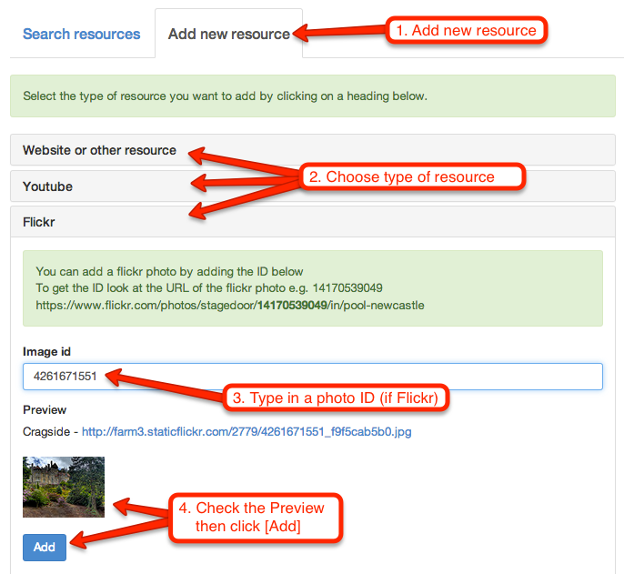
- For a Website/Web page add a URL and title (other fields are optional)

- For a video from YouTube type in (or copy and paste in) the video ID:

- For a photo from Flickr type in (or copy and paste in) the Photo ID:
- If searching Flickr for resources to add please filter license on Creative Commons:
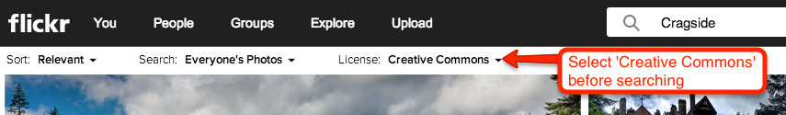

When resources are added from YouTube or Flickr information is automatically retrieved using the API (title, description, thumbnail, license etc). Also, when a resource is added it is instantly inserted into the search index.

Communities
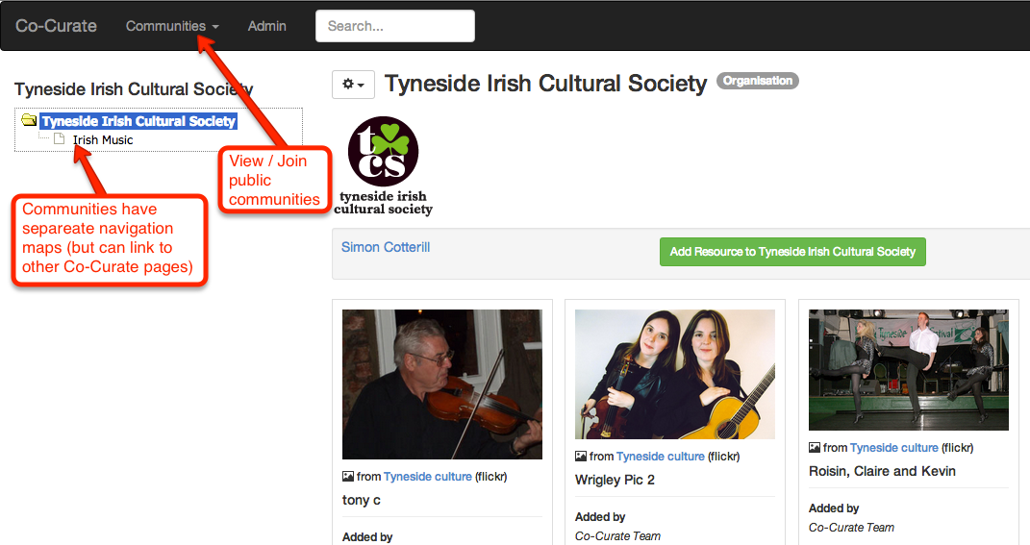

Adding comments
- Comments on topics and resources are made using Disqus (requires social login)
